**Title:** *Learning from DITA-CCMS Tool - Heretto*

**Introduction to Heretto**

**What is Heretto?**

• Heretto **is a DITA-CCMS** – A Component Content Management System (CCMS) designed for structured content using **DITA**.

• Streamlines **Content Creation & Management** – Enables efficient authoring, organizing, and reusing content.

• Omnichannel **Publishing** – Publish content to multiple platforms like PDFs, websites, chatbots, and apps.

• Collaboration **& Workflow Control** – Provides versioning, workflows, and access control for teams.

• API**-First & Scalable** – Integrates with various tools and supports enterprise content needs.

**Why use Heretto?**

* + Single-source content management
  + Multichannel publishing
  + Workflow and collaboration tools

**Understanding DITA-CCMS**

(Go to shraddha’s ppt give link of it)

* **What is a CCMS?**

A **Component Content Management System (CCMS)** is a specialized system for managing structured content at a granular level. Unlike traditional CMS, which handles whole documents.

* + A system that manages modular, reusable content
  + Facilitates version control, localization, and publishing
* **CCMS vs. Traditional CMS**

| **Feature** | **(DITA-CCMS)** | **Traditional CMS** |
| --- | --- | --- |
| Content Structure | XML-based, modular | Unstructured or semi-structured |
| Reusability | High (DITA topics) | Low (copy-paste) |
| Version Control | Strong version tracking | Limited |
| Multichannel Output | Web, PDF, mobile, chatbots | Mostly web |
| Collaboration /Role based Access | Workflow-based | Basic collaboration |
|  |  |  |

**Key Features of Heretto**

* Structured Authoring with DITA
* Content Reusability & Version Control
* Real-time Collaboration
* Multichannel Publishing (Web, PDF, Chatbots, etc.)
* Content Localization & Translation Management
* API Integrations & Customization

**Benefits of Using Heretto**

* **Increases Efficiency** – Write once, reuse multiple times
* **Improves Collaboration** – Teams work together seamlessly
* **Enhances Content Accuracy** – Version control prevents errors
* **Supports Omnichannel Publishing** – Deliver content to multiple platforms
* **Ensures Regulatory Compliance** – Manage documentation with audit trails

**Heretto Workflow**

* **Content Creation:** Author content using DITA
* **Content Management:** Store, version, and reuse content
* **Review & Collaboration:** Assign workflows, approve, and edit
* **Publishing:** Deliver content across different platforms

**More about Heretto:**

<https://help.heretto.com/en> :-Heretto ccms

Heretto deploy

Heretto Portal

<https://conga-staging.portal.heretto.com/en> :-Conga product documentation.

**CCMS Platforms Other than Heretto**

• Paligo – Cloud-based CCMS with structured authoring and version control.

• IXIASOFT **CCMS** – Scalable DITA-based solution with advanced workflow management.

• Adobe **Experience Manager Guides** – AI-powered, enterprise-grade CCMS with seamless integration.

• Vasont **CCMS** – XML-based platform with workflow automation and multi-channel publishing.

• SDL **Tridion Docs** – AI-driven structured content management for global enterprises.

**Use Cases of Heretto**

**Why conga used hereto as CCMS**

Conga documents were in confluence first which is also a CCMS but because it is converted into Heretto because it is good for content management and storage.

**How Conga is Used in Heretto:**

Content Mapping – Conga analyzes and maps existing content to DITA structures for better organization.

Content Transformation – Converts unstructured content into structured DITA topics and components.

Validation & Quality Check – Ensures content follows DITA standards and checks for errors.

Review & Approval – Content is reviewed, refined, and approved through workflow management.

Publishing – The validated content is published across multiple formats (PDFs, websites, apps, etc.).

**Demo or Screenshots(Conga)**

**

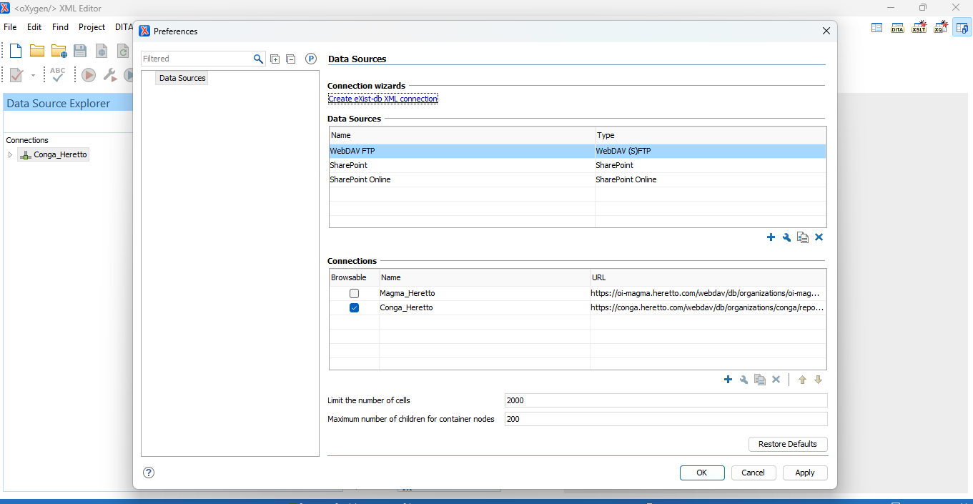

**Challenges & Considerations**

* **Learning Curve** – Requires understanding of DITA
* **Implementation Costs** – Cloud-based subscription
* **Integration Needs** – API support for other tools

**Conclusion**

* **Heretto is a powerful DITA-CCMS tool for structured content management**
* **Ideal for organizations needing scalable, reusable content solutions**
* **Enhances efficiency, collaboration, and publishing capabilities**